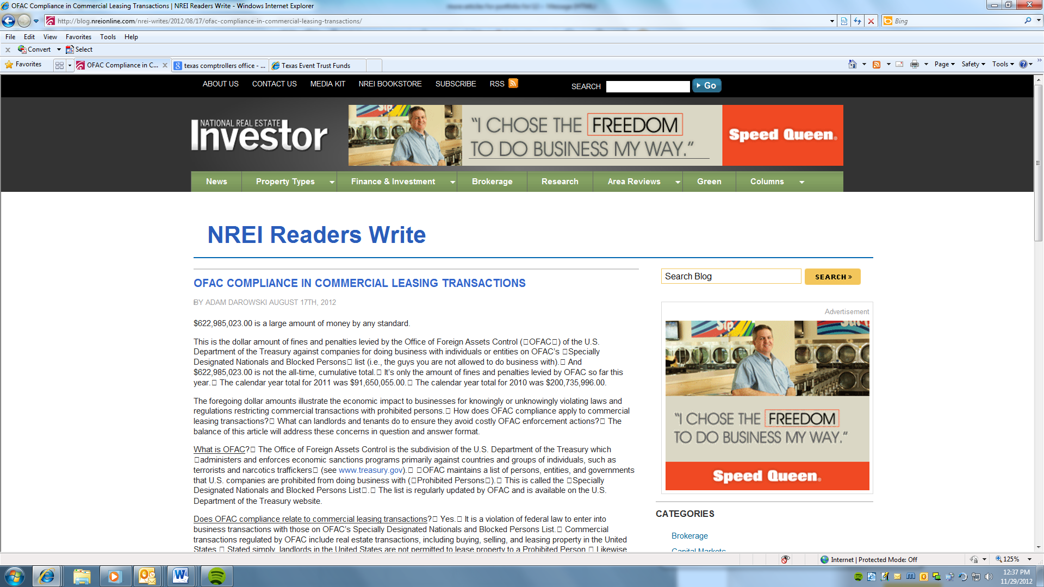

OFAC Compliance in Commercial Leasing Transactions
by Adam Darowski August 17th, 2012
$622,985,023.00 is a large amount of money by any standard.
This is the dollar amount of fines and penalties levied by the Office of Foreign Assets Control (OFAC) of the U.S. Department of the Treasury against companies for doing business with individuals or entities on OFAC’s Specially Designated Nationals and Blocked Persons list (i.e., the guys you are not allowed to do business with). And $622,985,023.00 is not the all-time, cumulative total. It’s only the amount of fines and penalties levied by OFAC so far this year. The calendar year total for 2011 was $91,650,055.00. The calendar year total for 2010 was $200,735,996.00.
The foregoing dollar amounts illustrate the economic impact to businesses for knowingly or unknowingly violating laws and regulations restricting commercial transactions with prohibited persons. How does OFAC compliance apply to commercial leasing transactions? What can landlords and tenants do to ensure they avoid costly OFAC enforcement actions? The balance of this article will address these concerns in question and answer format.
What is OFAC? The Office of Foreign Assets Control is the subdivision of the U.S. Department of the Treasury which administers and enforces economic sanctions programs primarily against countries and groups of individuals, such as terrorists and narcotics traffickers (see www.treasury.gov). OFAC maintains a list of persons, entities, and governments that U.S. companies are prohibited from doing business with (Prohibited Persons). This is called the Specially Designated Nationals and Blocked Persons List. The list is regularly updated by OFAC and is available on the U.S. Department of the Treasury website.
Does OFAC compliance relate to commercial leasing transactions? Yes. It is a violation of federal law to enter into business transactions with those on OFAC’s Specially Designated Nationals and Blocked Persons List. Commercial transactions regulated by OFAC include real estate transactions, including buying, selling, and leasing property in the United States. Stated simply, landlords in the United States are not permitted to lease property to a Prohibited Person. Likewise, tenants are not permitted to lease property from a Prohibited Person.
What are the penalties for entering into a prohibited transaction? Penalties for entering into commercial transactions with Prohibited Persons can include criminal fines ranging from $50,000 to $10,000,000, and imprisonment from 10 to 30 years for willful violations, and civil penalties ranging from $250,000 (or twice the amount of each underlying transaction) to $1,075,000.00 for each individual violation.
What steps can a landlord or tenant take to avoid entering into a prohibited leasing transaction?
As commercial landlords and tenants contemplate entering into leasing transactions, the likelihood of violating OFAC requirements can be reduced by implementing the following procedures:
1. Don’t simply assume the party on the other side of the deal is not a Prohibited Person.
2. Include some form of Prohibited Persons screening at the initial stages of a potential leasing transaction. Either through a third-party service provider, commercially-available software which is linked to the Prohibited Persons list, or an online search on the U.S. Department of the Treasury website, it is a prudent business practice to run a Prohibited Persons search on any potential party with which a landlord or tenant intends to enter into a transaction. This type of initial screening takes minutes, can be relatively inexpensive, and should be documented for the permanent lease file.
3. Landlords and tenants should require some sort of OFAC representation and indemnity in the lease itself. Inclusion of such a provision serves to mitigate a party’s liability for unknowingly entering into a lease with a Prohibited Person. A sample landlord-oriented provision is provided below:
Tenant represents and warrants to Landlord that Tenant is not a party with whom Landlord is prohibited from doing business pursuant to the regulations of the Office of Foreign Assets Control (OFAC) of the U.S. Department of the Treasury, including those parties named on OFAC’s Specially Designated Nationals and Blocked Persons List. Tenant is currently in compliance with, and shall at all times during the lease term remain in compliance with, the regulations of OFAC and any other governmental requirement relating thereto. In the event of any violation of this section, Landlord shall be entitled to immediately terminate this Lease and take such other actions as are permitted or required to be taken under law or in equity. TENANT SHALL DEFEND, INDEMNIFY AND HOLD HARMLESS LANDLORD FROM AND AGAINST ANY AND ALL CLAIMS, DAMAGES, LOSSES, RISKS, LIABILITIES AND EXPENSES (INCLUDING ATTORNEYS’ FEES AND COSTS) INCURRED BY LANDLORD ARISING FROM OR RELATED TO ANY BREACH OF THE FOREGOING CERTIFICATIONS. These indemnity obligations shall survive the expiration or earlier termination of this Lease.
4. Landlords and tenants should periodically re-run Prohibited Persons searches during the lease term to ensure ongoing compliance, and should document such searches for the permanent lease file.
These routine measures can go a long way towards avoiding OFAC compliance issues and costly penalties in commercial leasing transactions.
Adam Darowski is a shareholder in the Real Estate Development and Investments Practice Group at Winstead PC.

